Trinity Ev. Lutheran Church
August 30, 2026
Thirteenth Sunday After Trinity

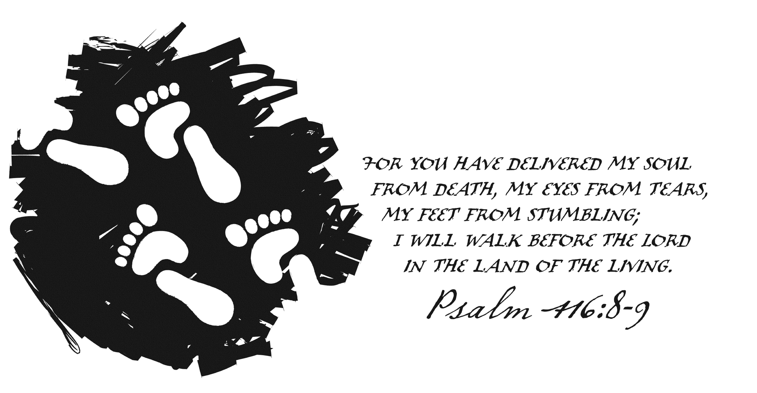

Worship Service 9:00AM
Sunday School 10:30AM
www.trinitylebanon.com
secretary@trinitylebanon.com

Confession and Absolution

477 Alleluia, Alleluia! Hearts to Heaven (Stand on verse 3)
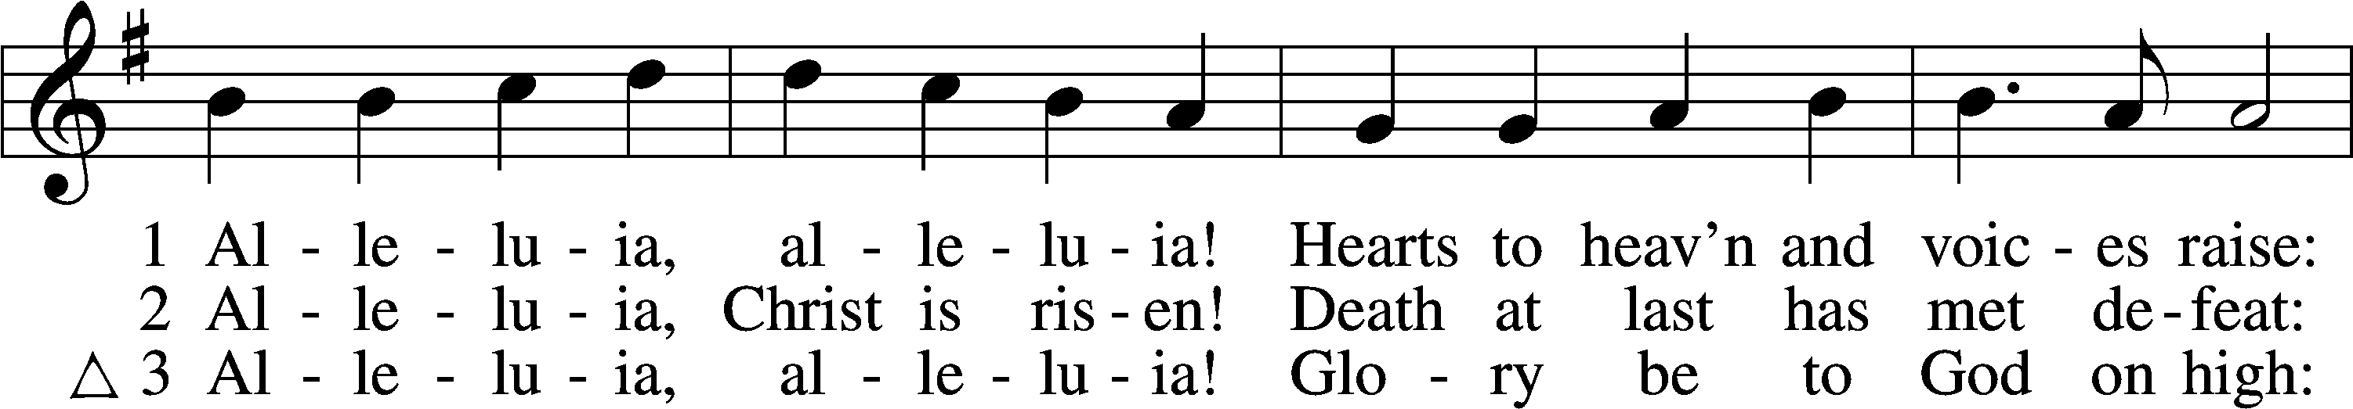
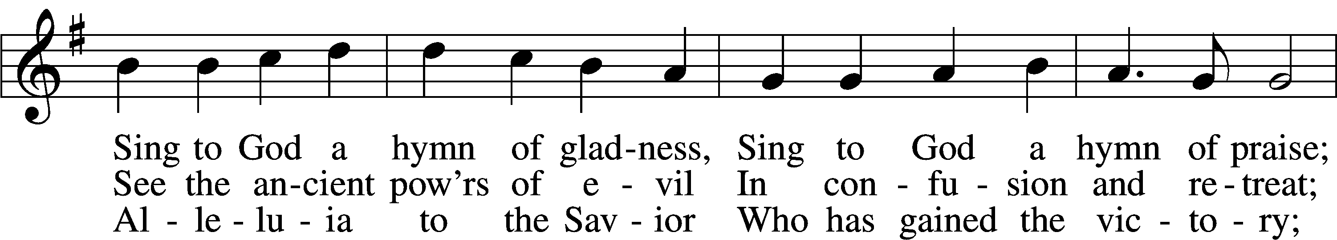
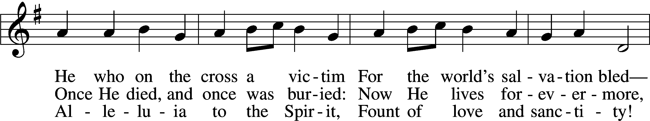
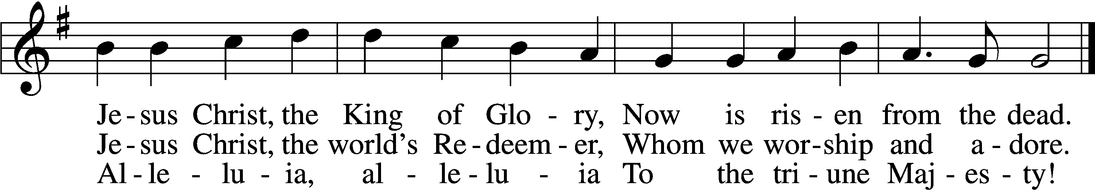
Text (sts. 1, 3): Christopher Wordsworth, 1807–85; (st. 2): rev. The Jubilate Group
Tune: Ludwig van Beethoven, 1770–1827; adapt. Edward Hodges, 1796–1867
Text (st. 2): © 1982 The Jubilate Group, admin. Hope Publishing Co. Used by permission: LSB Hymn License no. 110003399

The sign of the cross may be made by all in remembrance of their Baptism.

P In the name of the Father and of the T Son and of the Holy Spirit.
C Amen.

P If we say we have no sin, we deceive ourselves, and the truth is not in us.
C But if we confess our sins, God, who is faithful and just, will forgive our sins and cleanse us from all unrighteousness.

Silence for reflection on God’s Word and for self-examination.

P Let us then confess our sins to God our Father.
C Most merciful God, we confess that we are by nature sinful and unclean. We have sinned against You in thought, word, and deed, by what we have done and by what we have left undone. We have not loved You with our whole heart; we have not loved our neighbors as ourselves. We justly deserve Your present and eternal punishment. For the sake of Your Son, Jesus Christ, have mercy on us. Forgive us, renew us, and lead us, so that we may delight in Your will and walk in Your ways to the glory of Your holy name. Amen.

P Almighty God in His mercy has given His Son to die for you and for His sake forgives you all your sins. As a called and ordained servant of Christ, and by His authority, I therefore forgive you all your sins in the name of the Father and of the T Son and of the Holy Spirit.
C Amen.
Service of the Word
Kyrie LSB 152

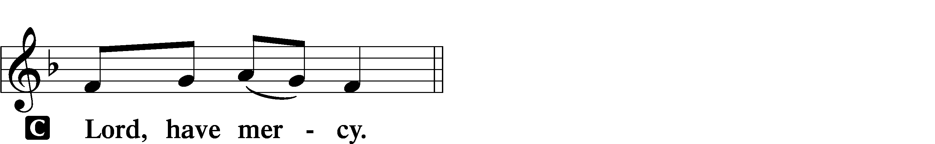
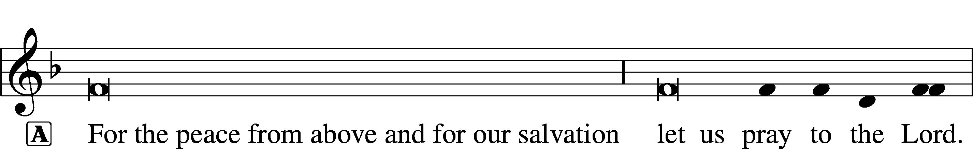

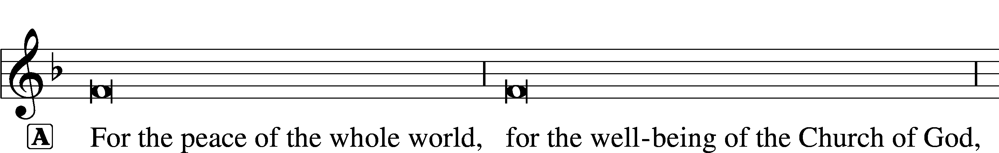


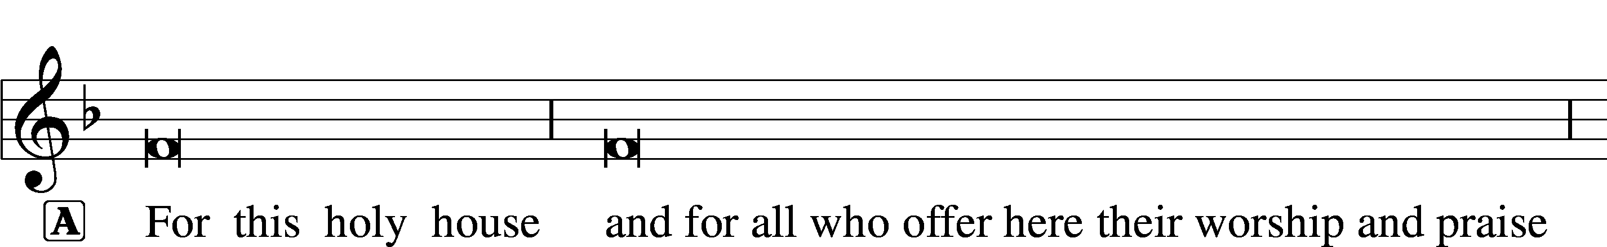





Gloria in Excelsis LSB 154
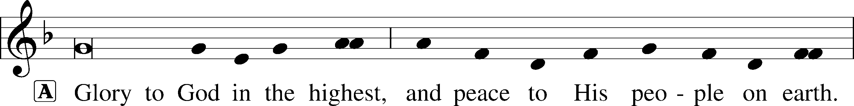
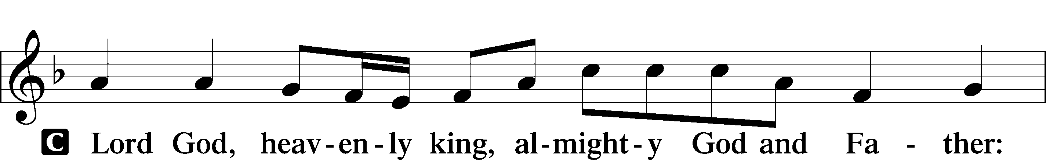
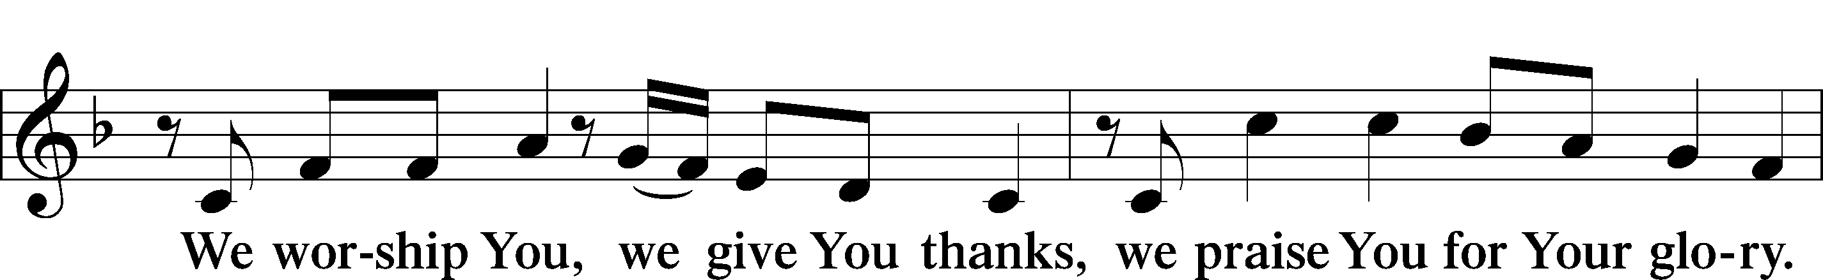
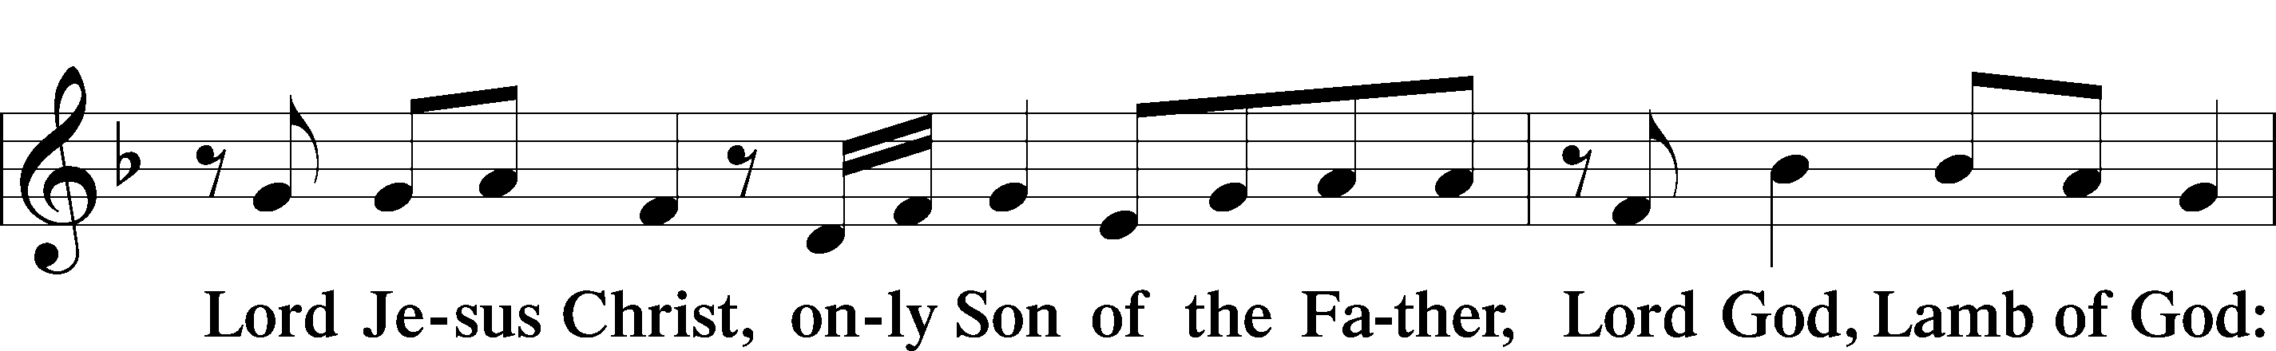
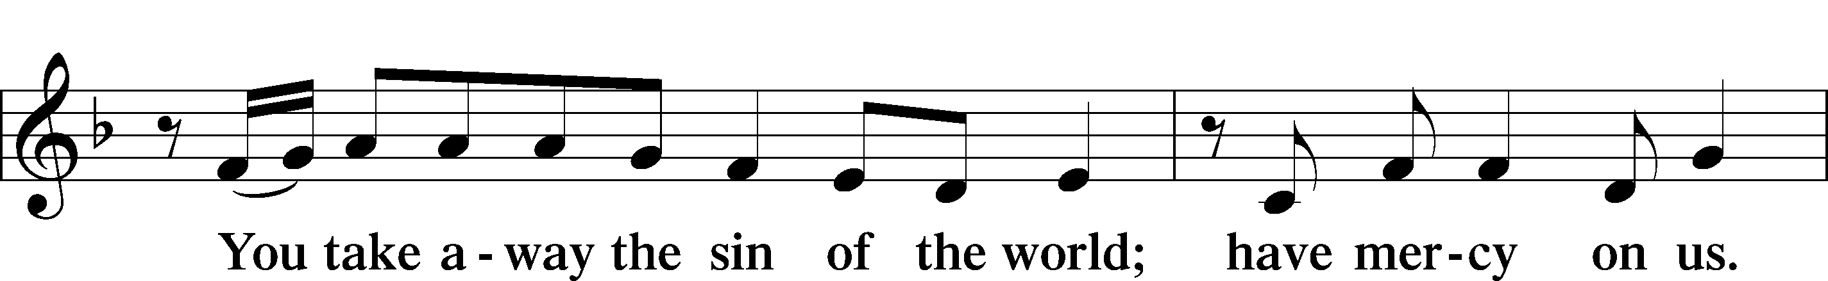
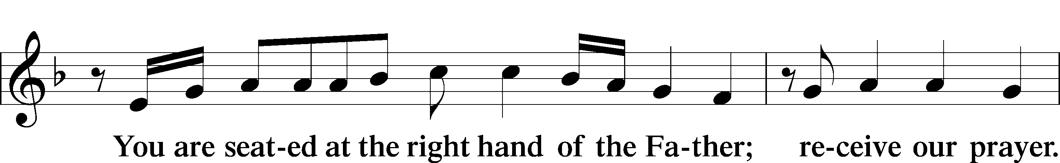
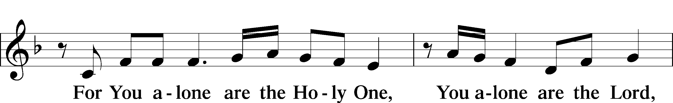
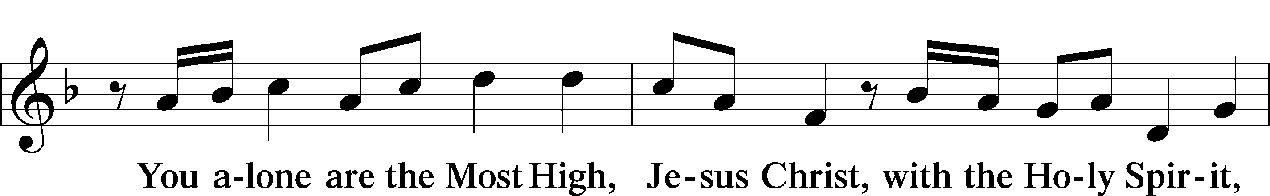
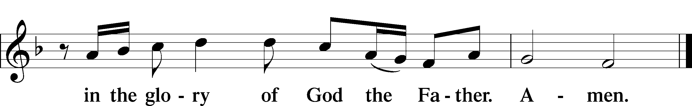

Salutation and Collect of the Day
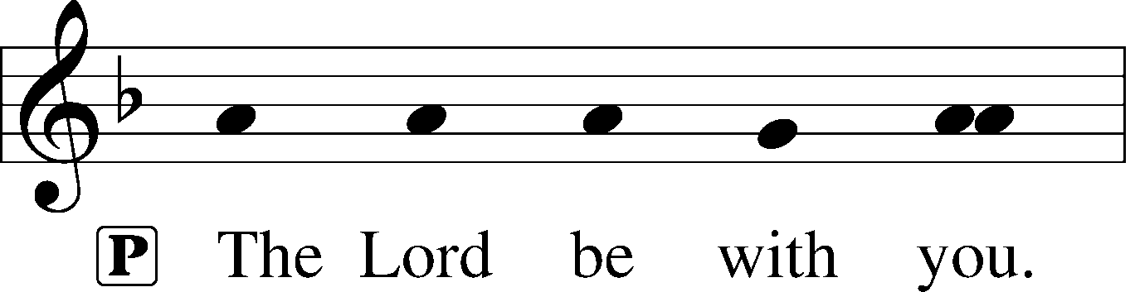
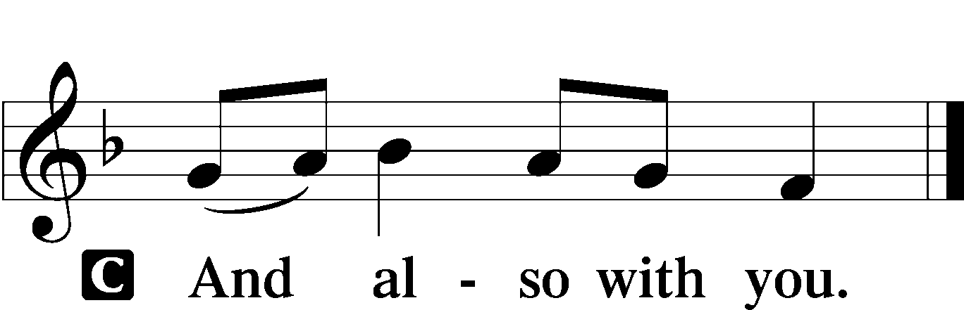

P Let us pray.
Almighty and everlasting God, give us an increase of faith, hope, and charity; and that we may obtain what You have promised, make us love what You have commanded; through Jesus Christ, Your Son, our Lord, who lives and reigns with You and the Holy Spirit, one God, now and forever.

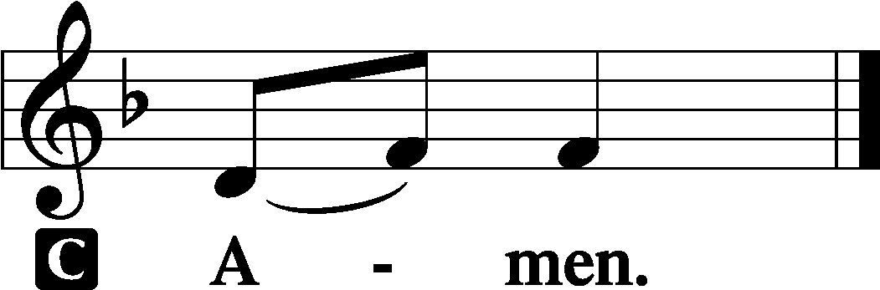

Sit

Old Testament Reading Genesis 6:5-7:24 (NASB95)
6:5 Then the Lord saw that the wickedness of man was great on the earth, and that every intent of the thoughts of his heart was only evil continually. 6 The Lord was sorry that He had made man on the earth, and He was grieved in His heart. 7 The Lord said, “I will blot out man whom I have created from the face of the land, from man to animals to creeping things and to birds of the sky; for I am sorry that I have made them.” 8 But Noah found favor in the eyes of the Lord.

9 These are the records of the generations of Noah. Noah was a righteous man, blameless in his time; Noah walked with God. 10 Noah became the father of three sons: Shem, Ham, and Japheth.

11 Now the earth was corrupt in the sight of God, and the earth was filled with violence. 12 God looked on the earth, and behold, it was corrupt; for all flesh had corrupted their way upon the earth.

13 Then God said to Noah, “The end of all flesh has come before Me; for the earth is filled with violence because of them; and behold, I am about to destroy them with the earth. 14 Make for yourself an ark of gopher wood…17 Behold, I, even I am bringing the flood of water upon the earth, to destroy all flesh in which is the breath of life, from under heaven; everything that is on the earth shall perish. 18 But I will establish My covenant with you; and you shall enter the ark—you and your sons and your wife, and your sons’ wives with you. 19 And of every living thing of all flesh, you shall bring two of every kind into the ark, to keep them alive with you; they shall be male and female. 20 Of the birds after their kind, and of the animals after their kind, of every creeping thing of the ground after its kind, two of every kind will come to you to keep them alive. 21 As for you, take for yourself some of all food which is edible, and gather it to yourself; and it shall be for food for you and for them.” 22 Thus Noah did; according to all that God had commanded him, so he did.

7:1 Then the Lord said to Noah, “Enter the ark, you and all your household, for you alone I have seen to be righteous before Me in this time. 2 You shall take with you of every clean animal by sevens, a male and his female; and of the animals that are not clean two, a male and his female; 3 also of the birds of the sky, by sevens, male and female, to keep offspring alive on the face of all the earth. 4 For after seven more days, I will send rain on the earth forty days and forty nights; and I will blot out from the face of the land every living thing that I have made.” 5 Noah did according to all that the Lord had commanded him…

11 In the six hundredth year of Noah’s life, in the second month, on the seventeenth day of the month, on the same day all the fountains of the great deep burst open, and the floodgates of the sky were opened. 12 The rain fell upon the earth for forty days and forty nights.

13 On the very same day Noah and Shem and Ham and Japheth, the sons of Noah, and Noah’s wife and the three wives of his sons with them, entered the ark, 14 they and every beast after its kind, and all the cattle after their kind, and every creeping thing that creeps on the earth after its kind, and every bird after its kind, all sorts of birds. 15 So they went into the ark to Noah, by twos of all flesh in which was the breath of life. 16 Those that entered, male and female of all flesh, entered as God had commanded him; and the Lord closed it behind him.

17 Then the flood came upon the earth for forty days, and the water increased and lifted up the ark, so that it rose above the earth. 18 The water prevailed and increased greatly upon the earth, and the ark floated on the surface of the water. 19 The water prevailed more and more upon the earth, so that all the high mountains everywhere under the heavens were covered. 20 The water prevailed fifteen cubits higher, and the mountains were covered. 21 All flesh that moved on the earth perished, birds and cattle and beasts and every swarming thing that swarms upon the earth, and all mankind; 22 of all that was on the dry land, all in whose nostrils was the breath of the spirit of life, died. 23 Thus He blotted out every living thing that was upon the face of the land, from man to animals to creeping things and to birds of the sky, and they were blotted out from the earth; and only Noah was left, together with those that were with him in the ark. 24 The water prevailed upon the earth one hundred and fifty days.

A This is the Word of the Lord.
C Thanks be to God.

Epistle 1 Peter 3:17-22 (NASB95)
17 For it is better, if God should will it so, that you suffer for doing what is right rather than for doing what is wrong. 18 For Christ also died for sins once for all, the just for the unjust, so that He might bring us to God, having been put to death in the flesh, but made alive in the spirit; 19 in which also He went and made proclamation to the spirits now in prison, 20 who once were disobedient, when the patience of God kept waiting in the days of Noah, during the construction of the ark, in which a few, that is, eight persons, were brought safely through the water. 21 Corresponding to that, baptism now saves you—not the removal of dirt from the flesh, but an appeal to God for a good conscience—through the resurrection of Jesus Christ, 22 who is at the right hand of God, having gone into heaven, after angels and authorities and powers had been subjected to Him.

A This is the Word of the Lord.
C Thanks be to God.

Stand

Alleluia and Verse LSB 156
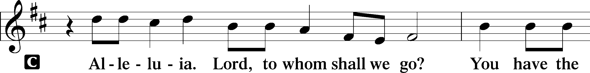
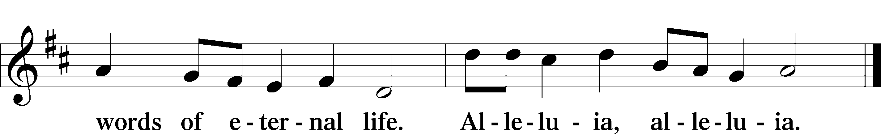

Holy Gospel Luke 17:26-30 (NASB95)
P The Holy Gospel according to St. Luke, the seventeenth chapter.

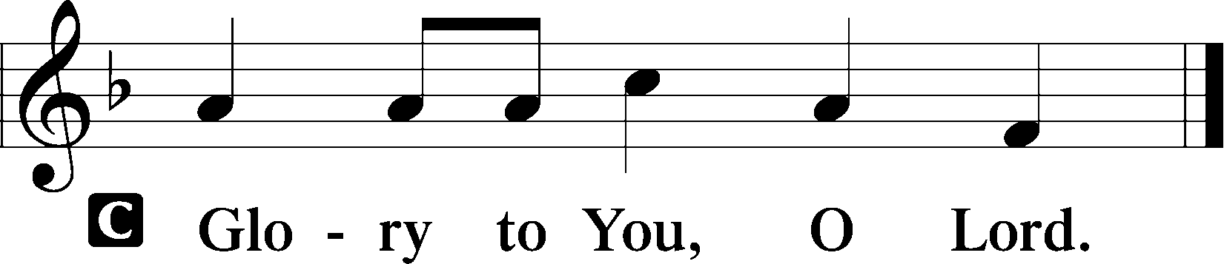

26 And just as it happened in the days of Noah, so it will be also in the days of the Son of Man: 27 they were eating, they were drinking, they were marrying, they were being given in marriage, until the day that Noah entered the ark, and the flood came and destroyed them all. 28 It was the same as happened in the days of Lot: they were eating, they were drinking, they were buying, they were selling, they were

planting, they were building; 29 but on the day that Lot went out from Sodom it rained fire and brimstone from heaven and destroyed them all. 30 It will be just the same on the day that the Son of Man is revealed.

P This is the Gospel of the Lord.

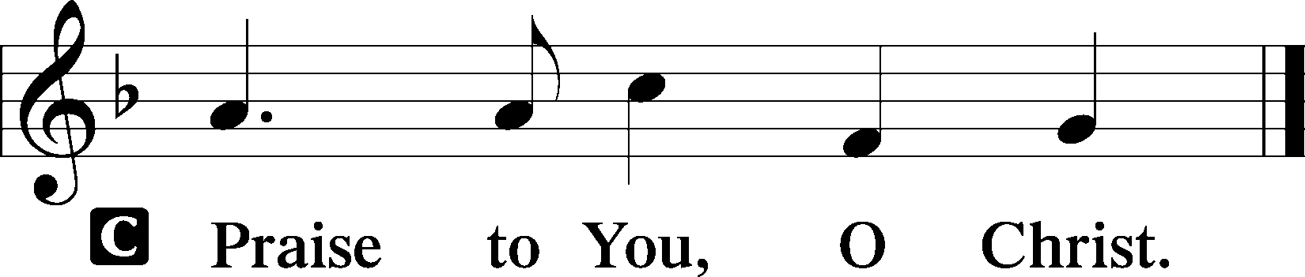

Sit

555 Salvation unto Us Has Come sts. 1–5
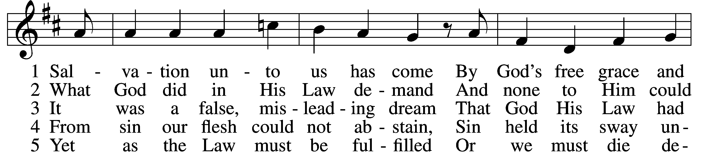
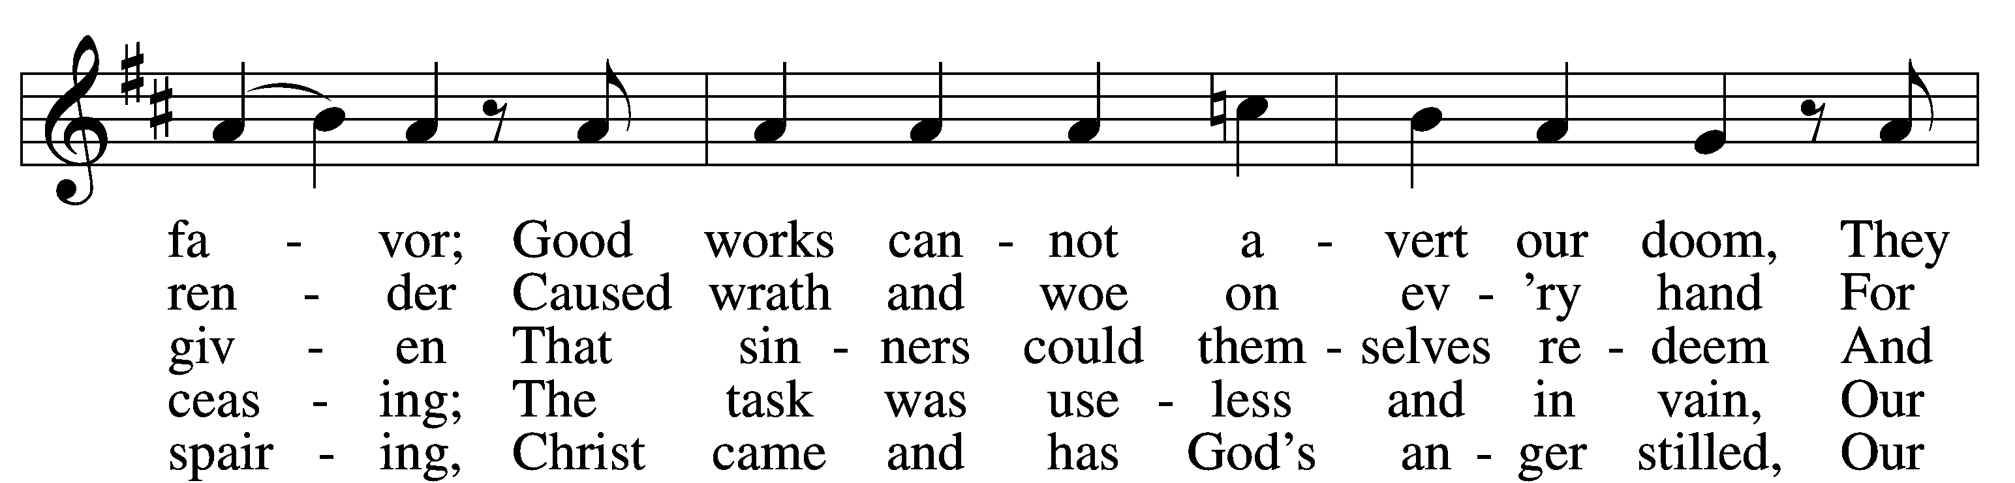
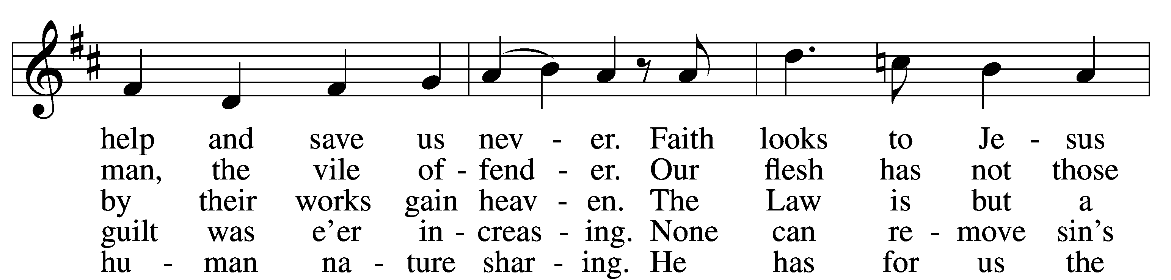
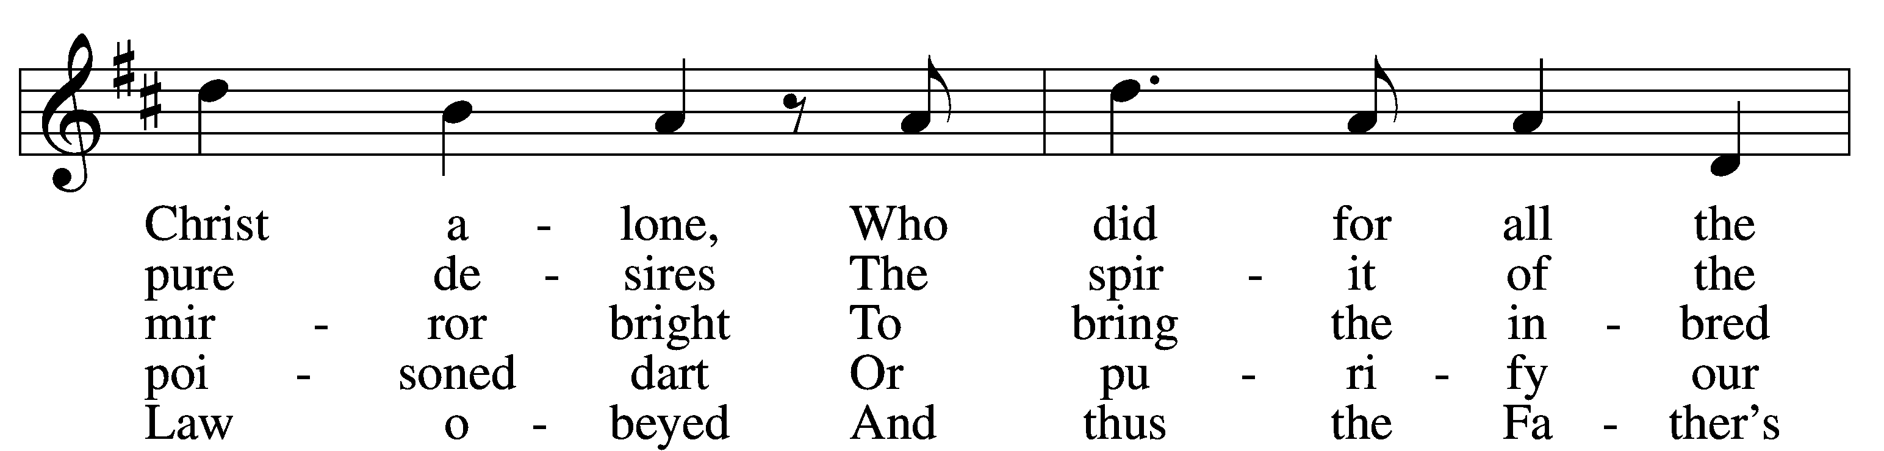
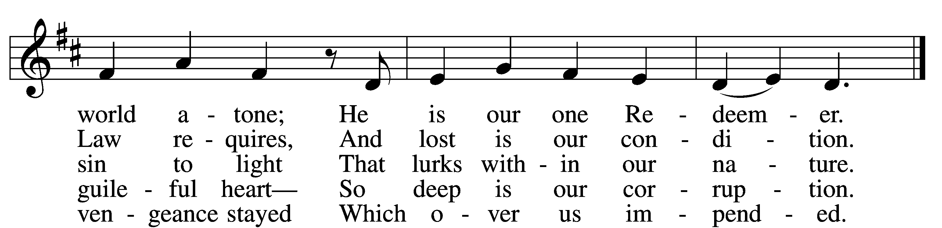
Text: Paul Speratus, 1484–1551; tr. The Lutheran Hymnal, 1941, alt.
Tune: Etlich Cristlich lider, 1524, Wittenberg

Sermon

Stand

Nicene Creed
C I believe in one God,
the Father Almighty,
maker of heaven and earth
and of all things visible and invisible.

And in one Lord Jesus Christ,
the only-begotten Son of God,
begotten of His Father before all worlds,
God of God, Light of Light,
very God of very God,
begotten, not made,
being of one substance with the Father,
by whom all things were made;

who for us men and for our salvation came down from heaven
and was incarnate by the Holy Spirit of the virgin Mary
and was made man;
and was crucified also for us under Pontius Pilate.
He suffered and was buried.
And the third day He rose again according to the Scriptures
and ascended into heaven
and sits at the right hand of the Father.
And He will come again with glory to judge both the living and the dead,
whose kingdom will have no end.

And I believe in the Holy Spirit,
the Lord and giver of life,
who proceeds from the Father and the Son,
who with the Father and the Son together is worshiped and glorified,
who spoke by the prophets.
And I believe in one holy Christian and apostolic Church,
I acknowledge one Baptism for the remission of sins,
and I look for the resurrection of the dead
and the life T of the world to come. Amen.

Prayer of the Church

Presentation of Offering

Stand

Offertory LSB 159
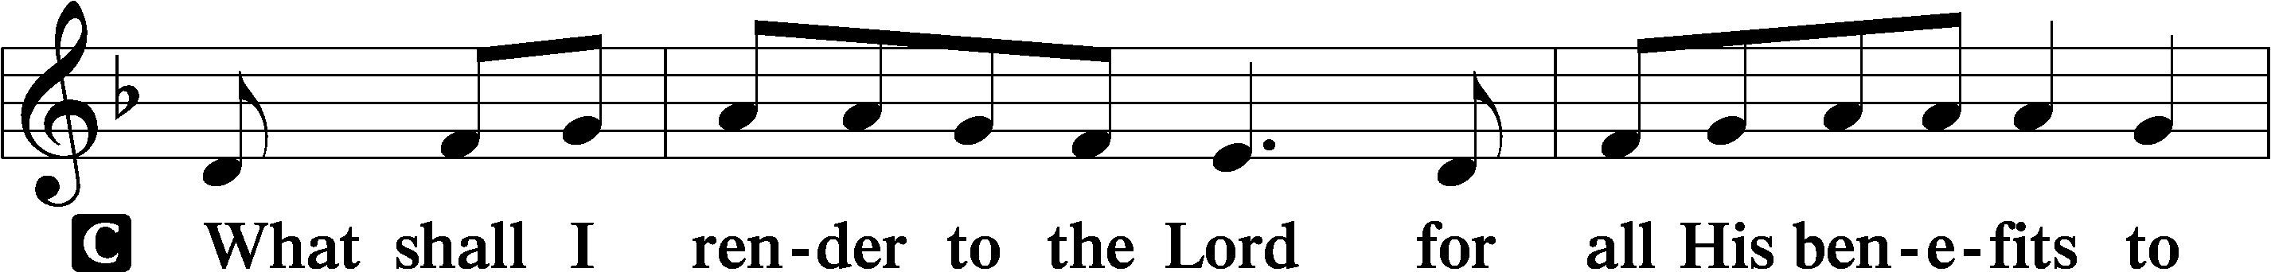
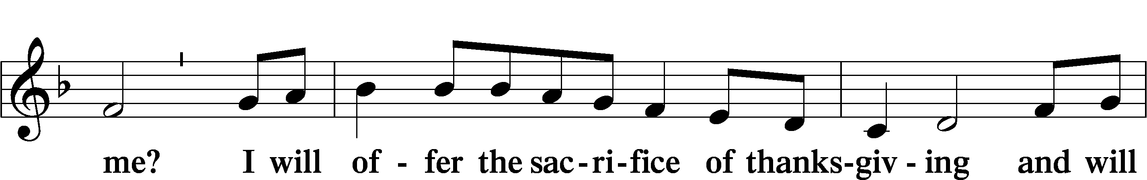
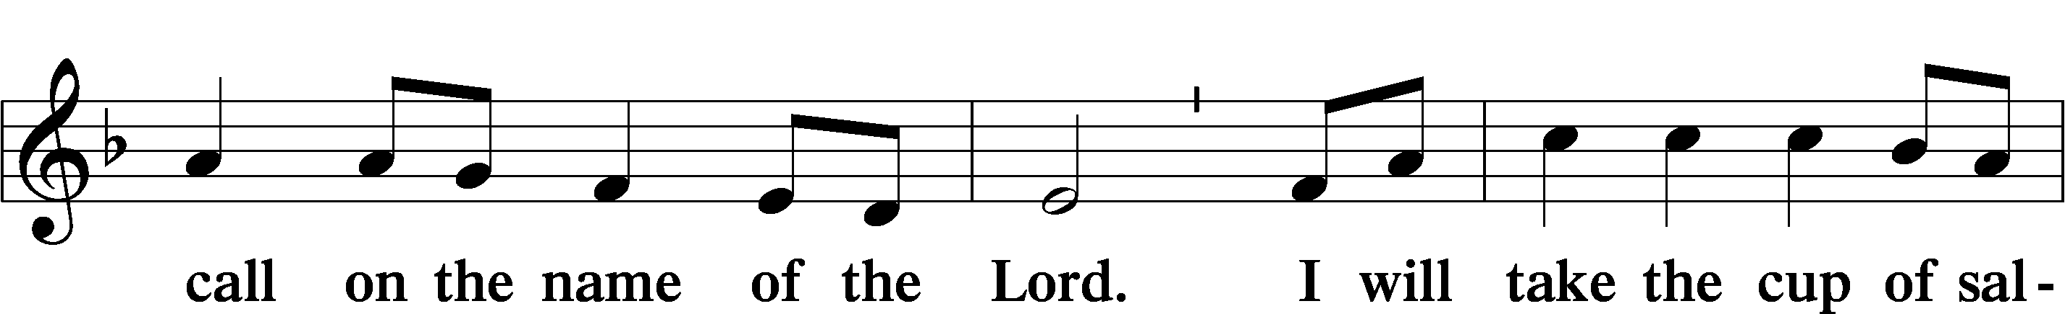
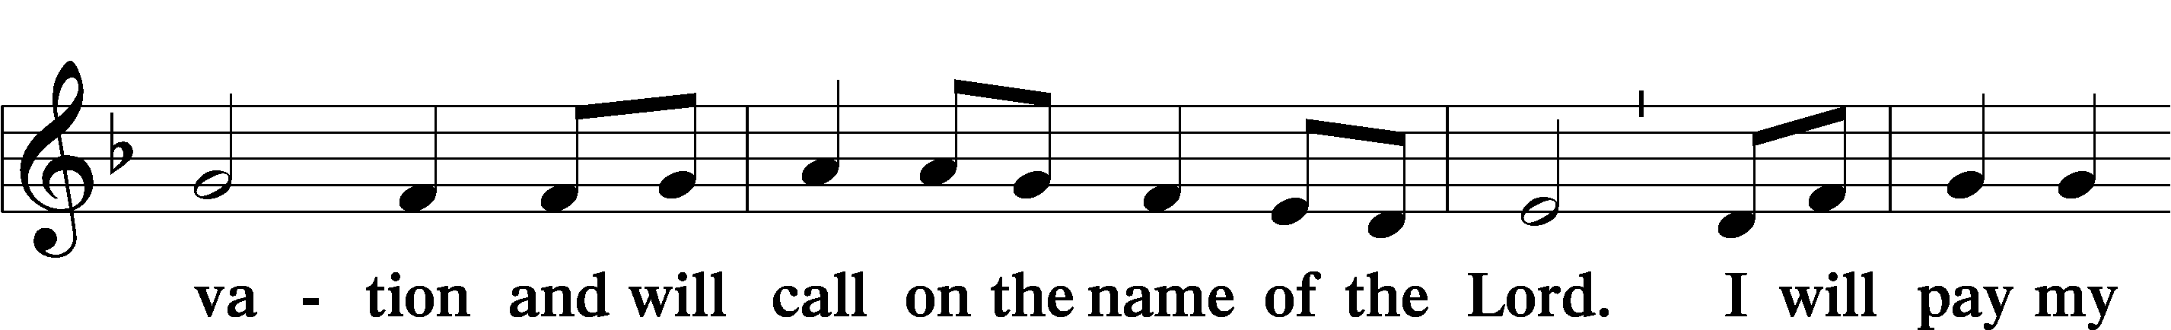
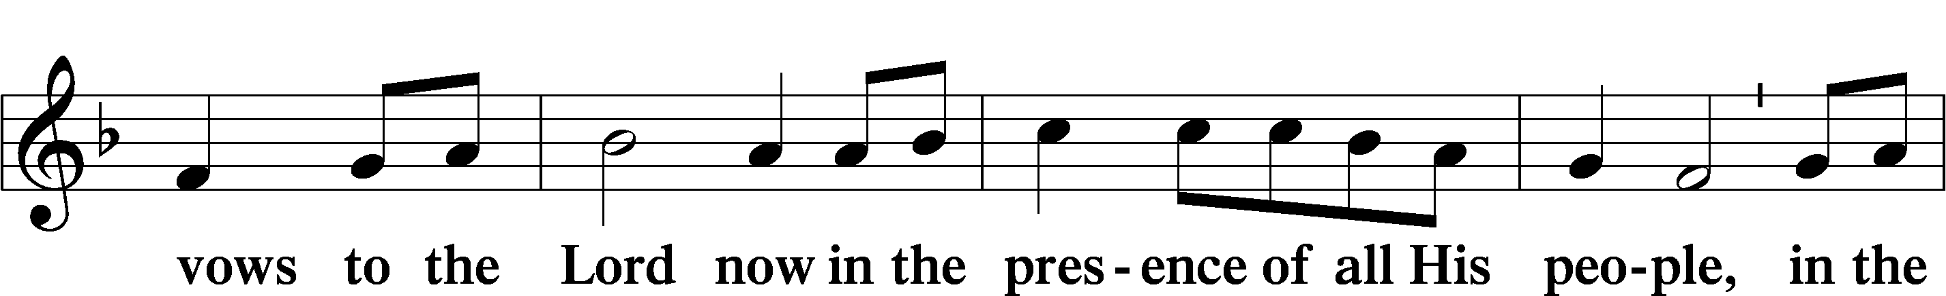
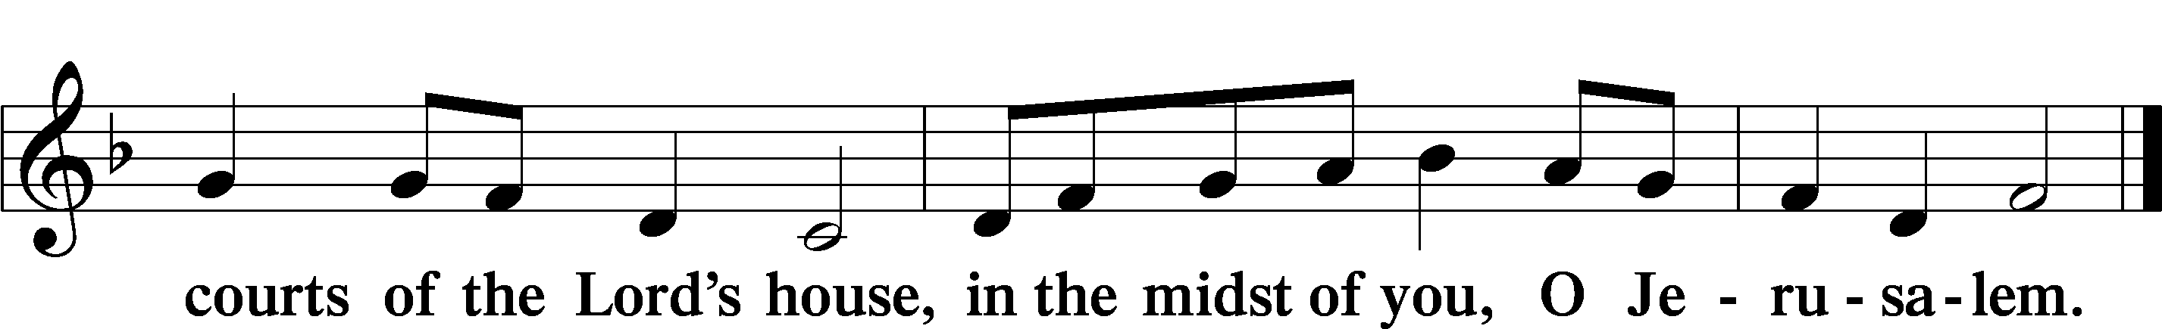

Communion Invitation
We acknowledge that oneness in doctrine is witnessed to by those receiving the Sacrament together. We, therefore, ask that non-LCMS guests desiring to commune would speak with the pastor before the service. Anyone may receive a blessing at the communion rail. Simply fold your arms and bow your head while kneeling at the rail. On each tray, center cup, has only a small amount of wine mixed with water for those who require it.

Service of the Sacrament
Preface LSB 160





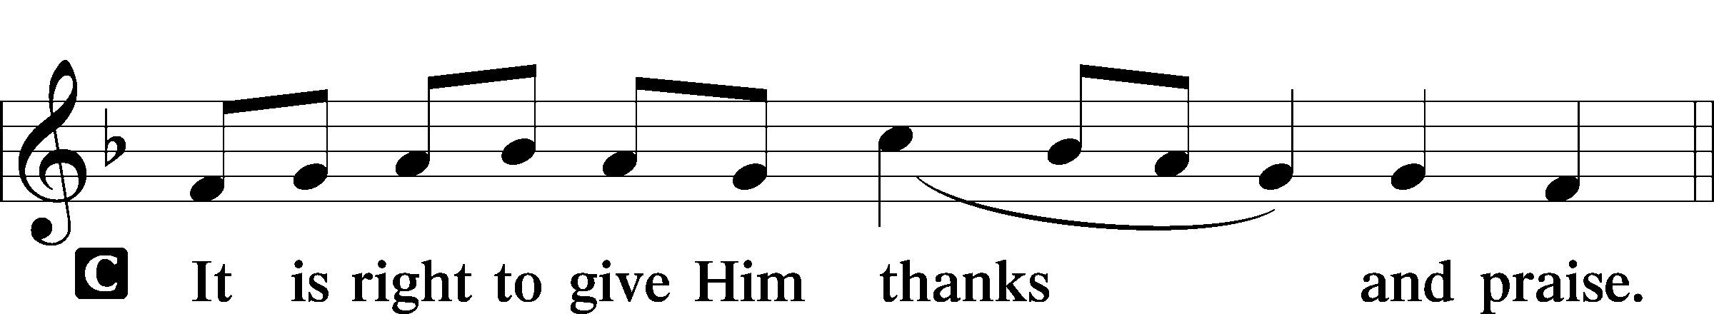

P It is truly good, right, and salutary that we should at all times and in all places give thanks to You, holy Lord, almighty Father, everlasting God, through Jesus Christ, our Lord, who, having created all things, took on human flesh and was born of the virgin Mary. For our sake He died on the cross and rose from the dead to put an end to death, thus fulfilling

Your will and gaining for You a holy people. Therefore with angels and archangels and with all the company of heaven we laud and magnify
Your glorious name, evermore praising You and saying:

Sanctus LSB 161
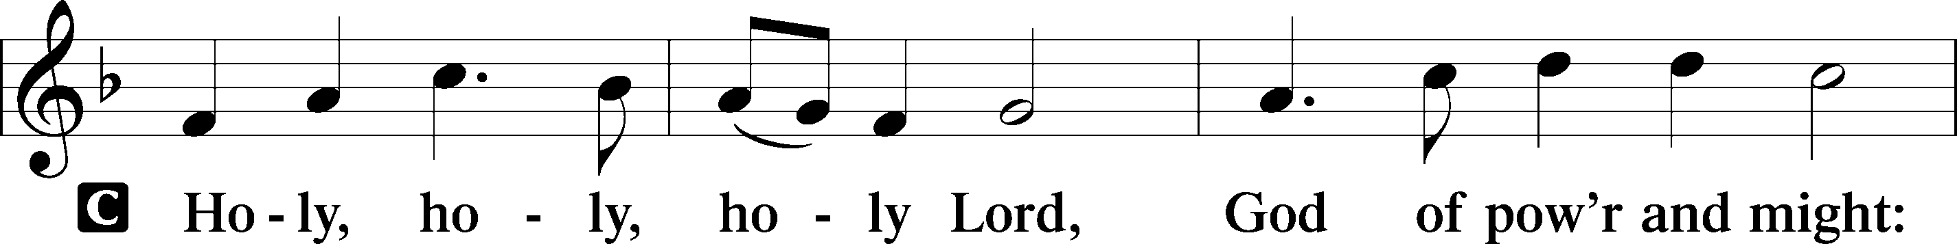
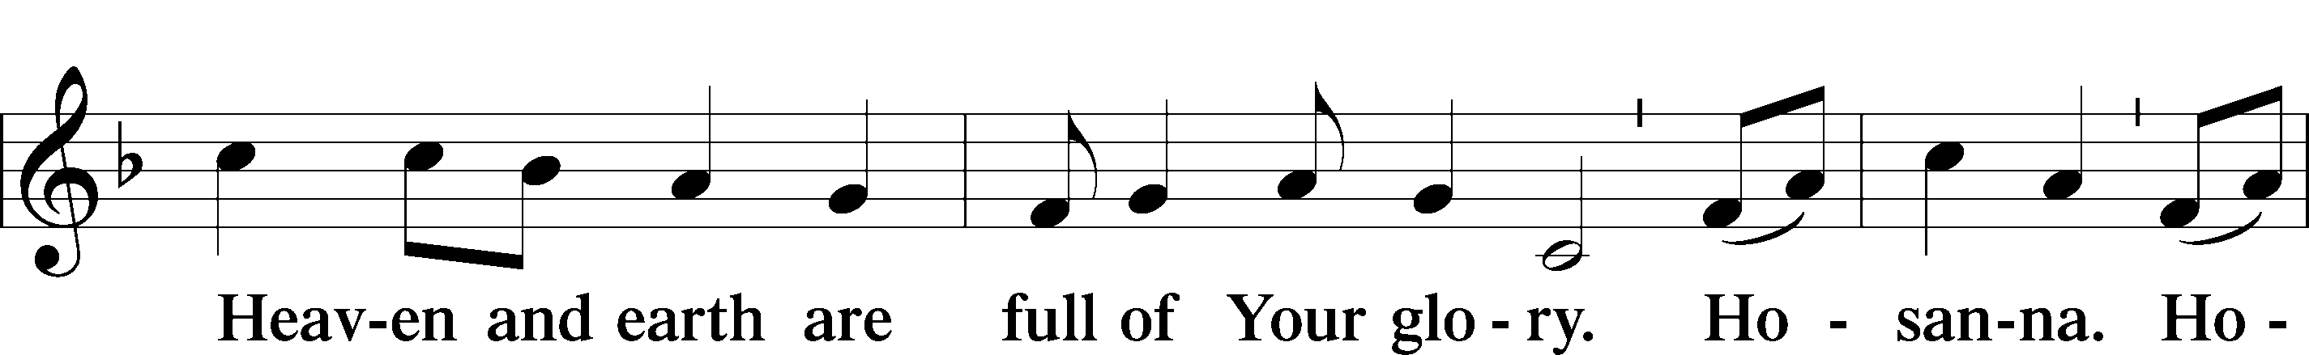
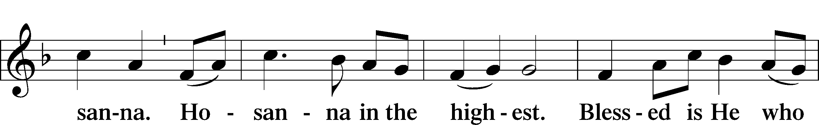
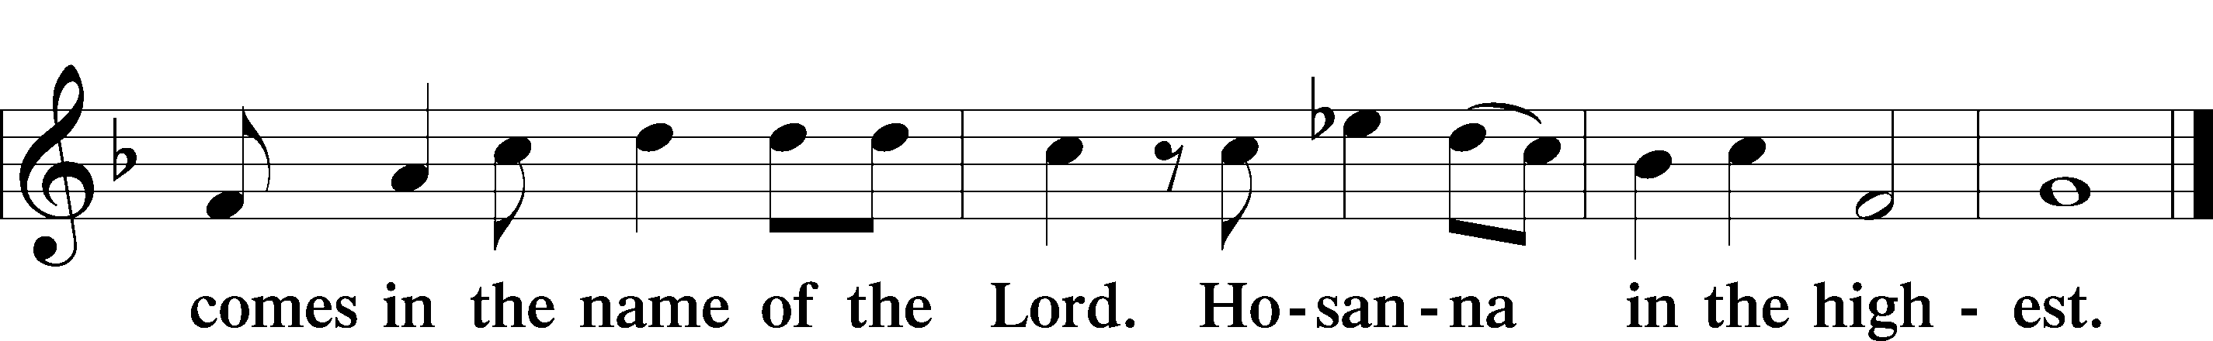

Prayer of Thanksgiving LSB 161
P Blessed are You, Lord of heaven and earth, for You have had mercy on those whom You created and sent Your only-begotten Son into our flesh to bear our sin and be our Savior. With repentant joy we receive the salvation accomplished for us by the all-availing sacrifice of His body and His blood on the cross.

Gathered in the name and the remembrance of Jesus, we beg You, O Lord, to forgive, renew, and strengthen us with Your Word and Spirit. Grant us faithfully to eat His body and drink His blood as He bids us do in His own testament. Gather us together, we pray,

from the ends of the earth to celebrate with all the faithful the marriage feast of the Lamb in His kingdom, which has no end. Graciously receive our prayers; deliver and preserve us. To You alone, O Father, be all glory, honor, and worship, with the Son and the Holy Spirit, one God, now and forever.
C Amen.

Lord’s Prayer
P Lord, remember us in Your kingdom and teach us to pray:
C Our Father who art in heaven,
hallowed be Thy name,
Thy kingdom come,
Thy will be done on earth
as it is in heaven;
give us this day our daily bread;
and forgive us our trespasses
as we forgive those
who trespass against us;
and lead us not into temptation,
but deliver us from evil.
For Thine is the kingdom
and the power and the glory
forever and ever. Amen.

The Words of Our Lord
P Our Lord Jesus Christ, on the night when He was betrayed, took bread, and when He had given thanks, He broke it and gave it to the disciples and said: “Take, eat; this is My T body, which is given for you. This do in remembrance of Me.”

In the same way also He took the cup after supper, and when He had given thanks, He gave it to them, saying: “Drink of it, all of you; this cup is the new testament in My T blood, which is shed for you for the forgiveness of sins. This do, as often as you drink it, in remembrance of Me.”

Pax Domini LSB 163
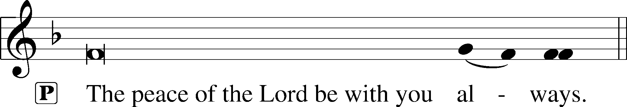


Agnus Dei LSB 163
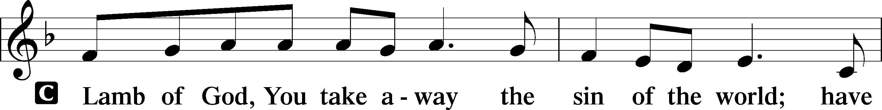
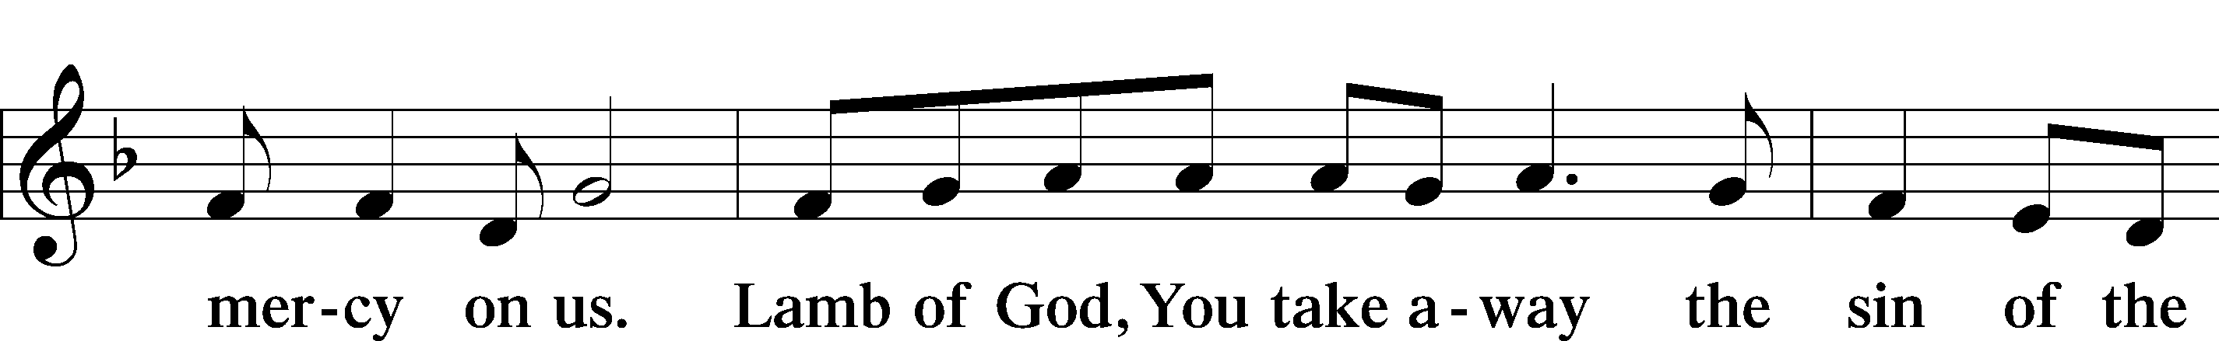

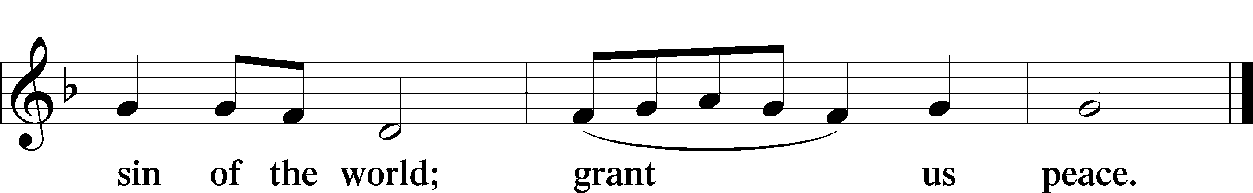

Sit
Distribution

537 Beautiful Savior
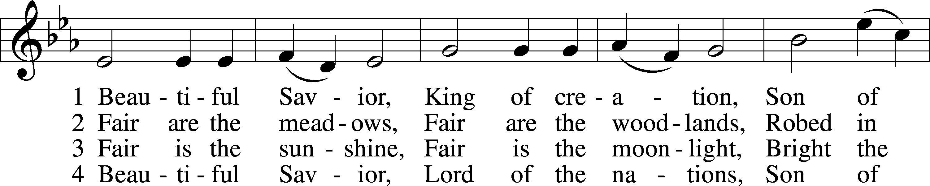
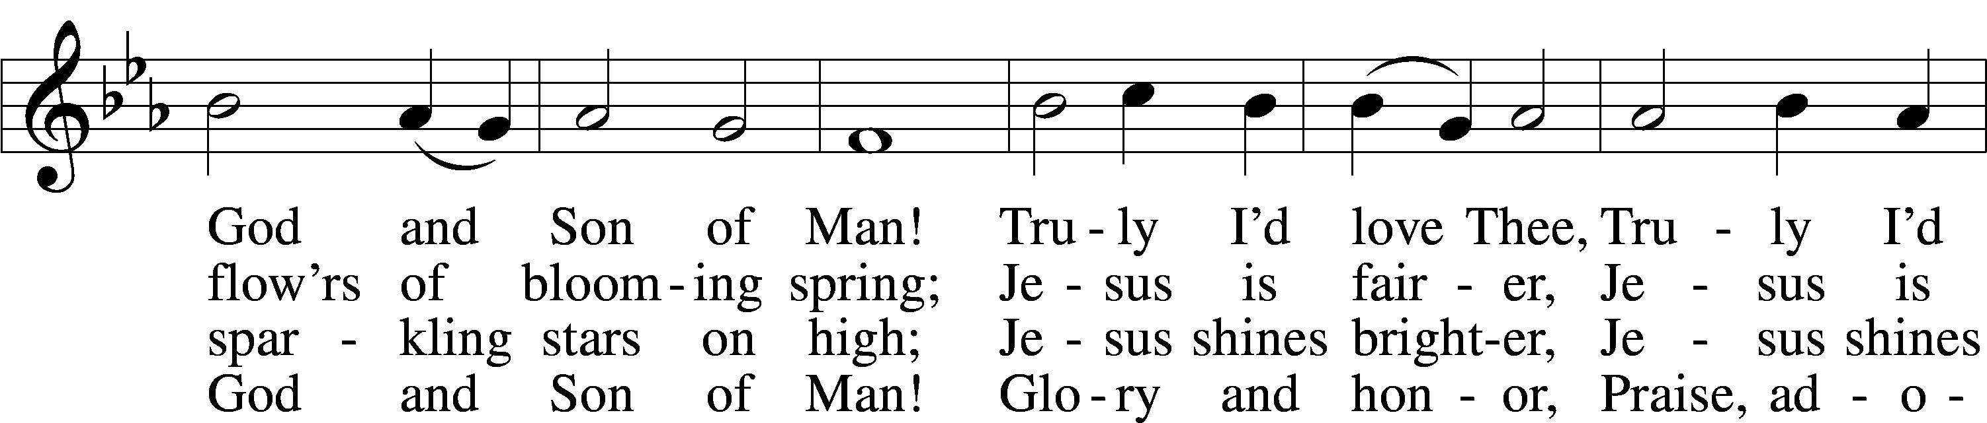
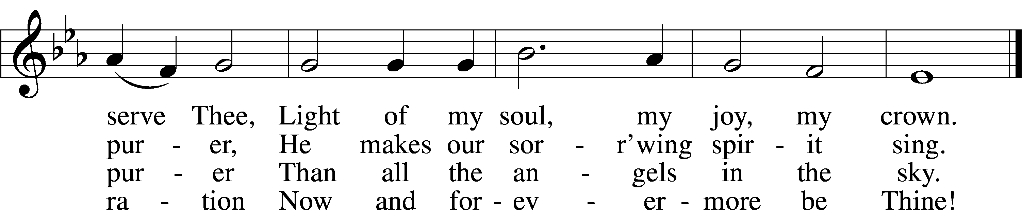
Text: Münsterisch Gesangbuch, 1677, Münster; tr. Joseph A. Seiss, 1823–1904
Tune: Silesian, 19th cent.
694 Thee Will I Love, My Strength, My Tower
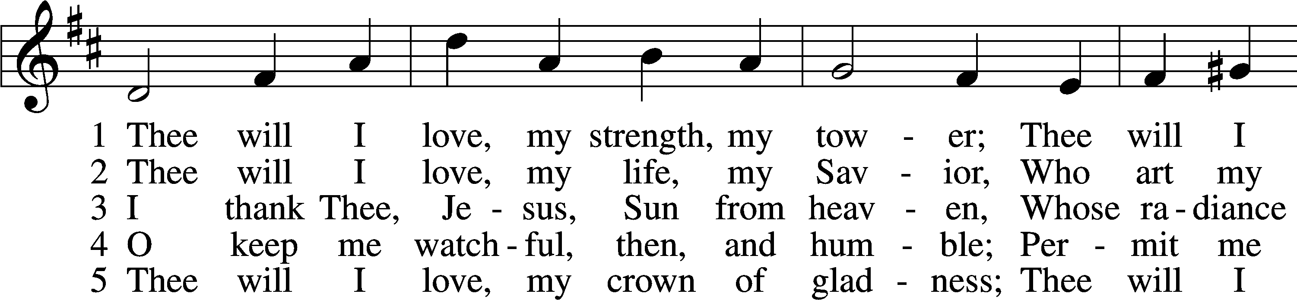
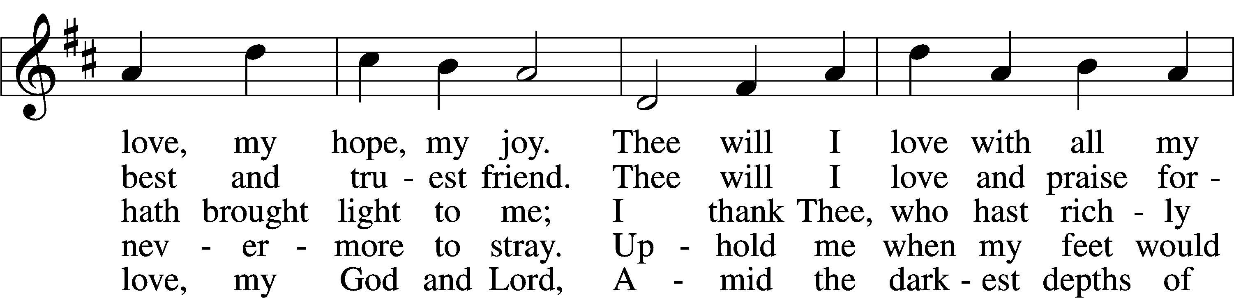
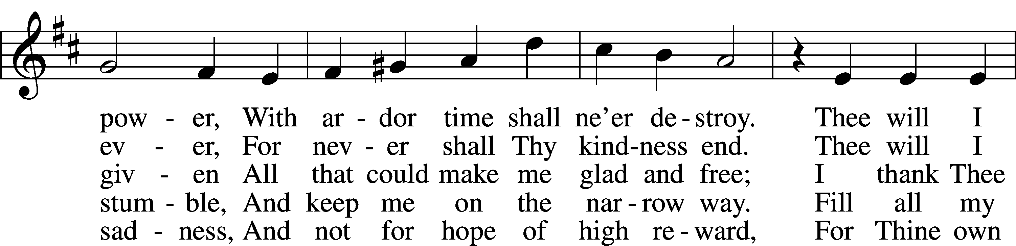
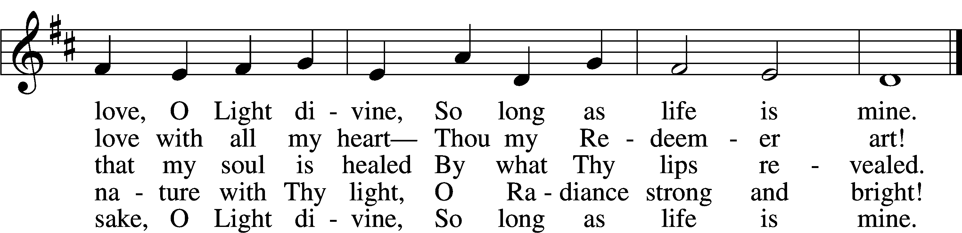
Text: Johann Scheffler, 1624–77; tr. Catherine Winkworth, 1827–78, alt.
Tune: Harmonischer Lieder-Schatz, 1738, Frankfurt

702 My Faith Looks Up to Thee
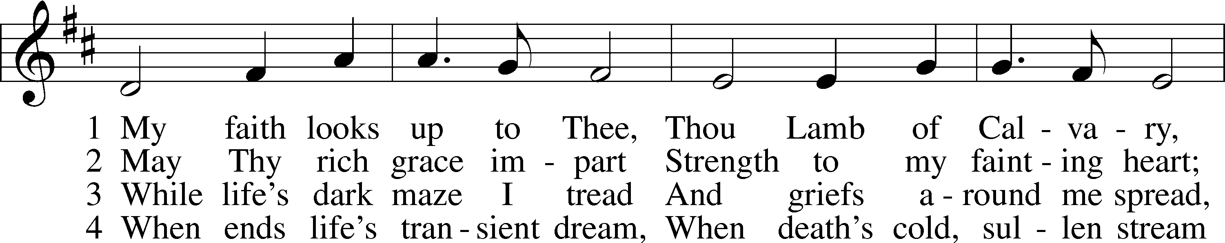
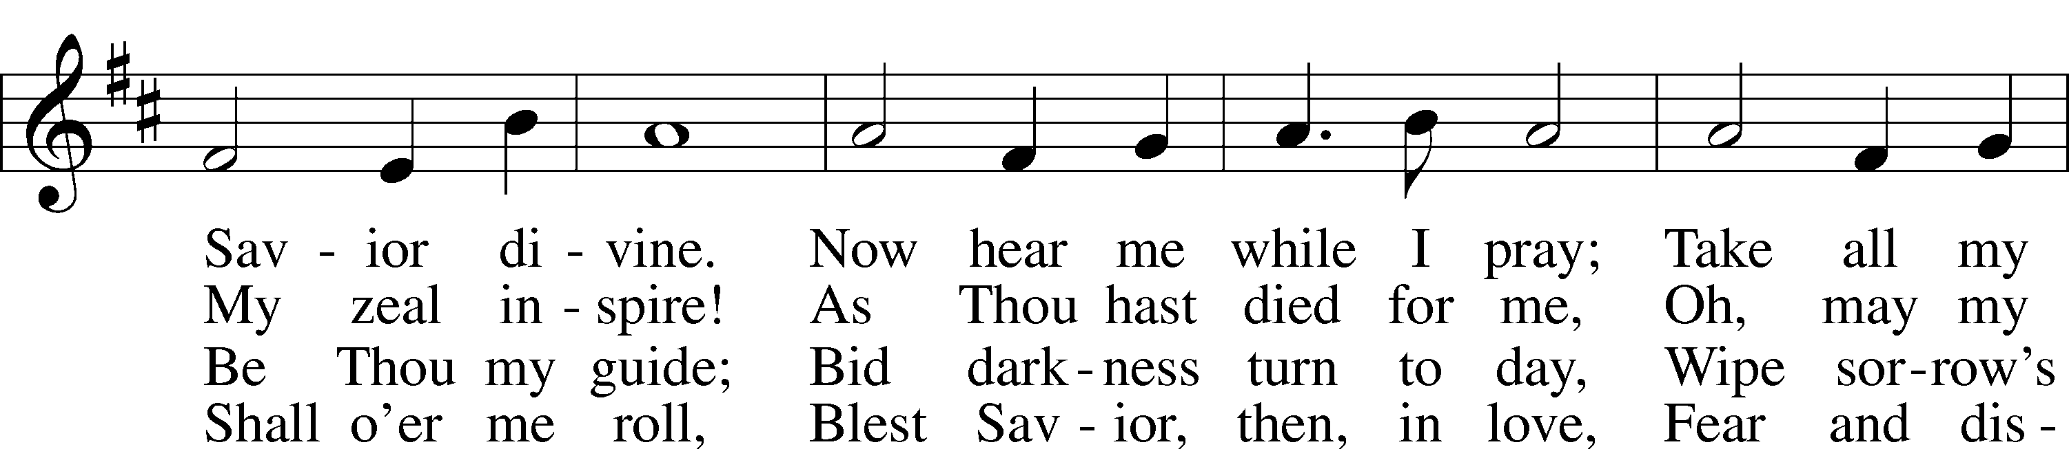
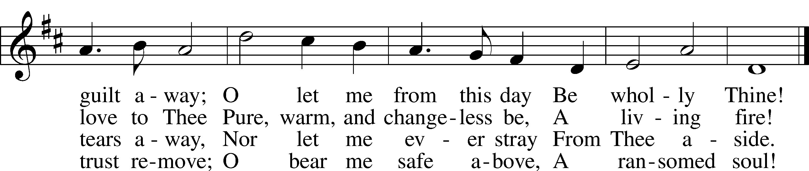
Text: Ray Palmer, 1808–87
Tune: Lowell Mason, 1792–1872

Stand

Thank the Lord LSB 164
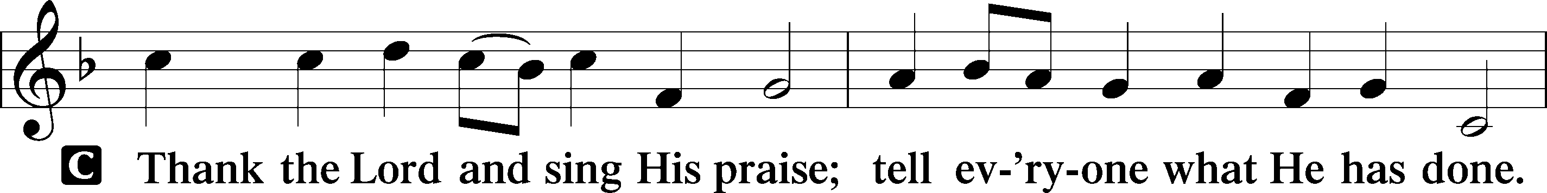
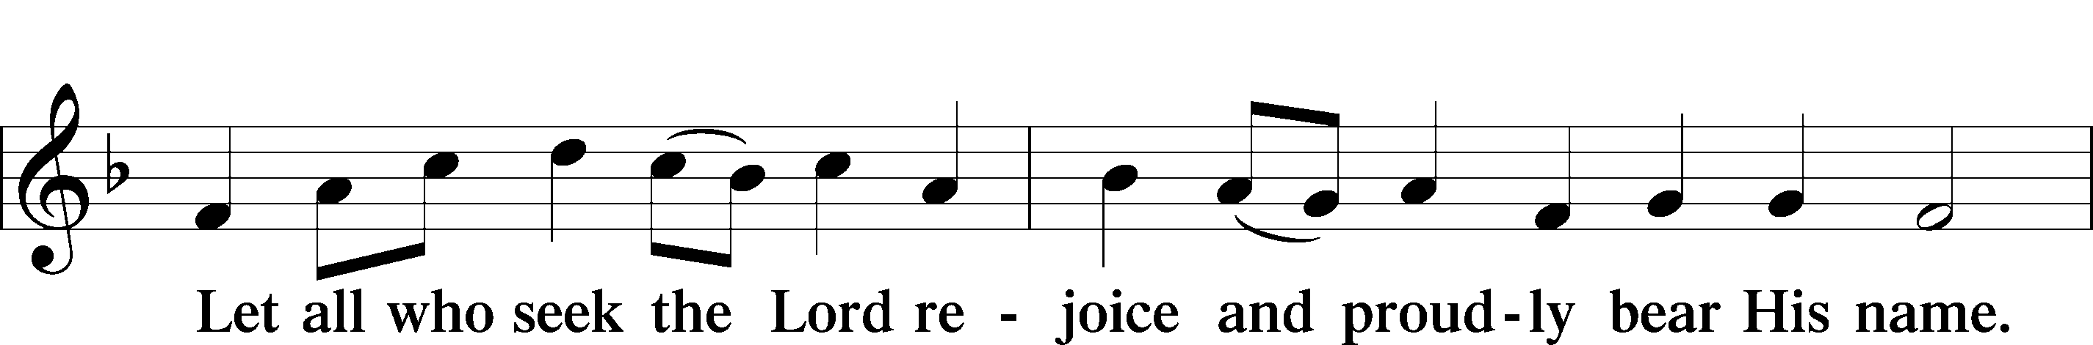
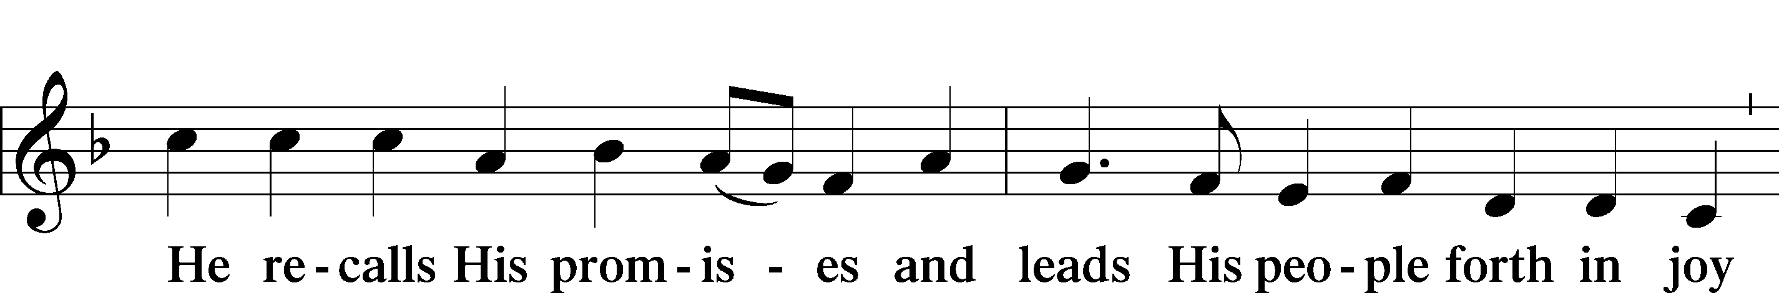
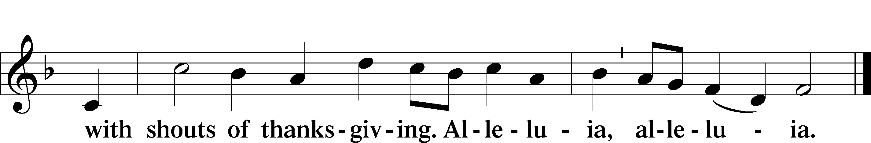

Post-Communion Collect
A Let us pray.
We give thanks to You, almighty God, that You have refreshed us through this salutary gift, and we implore You that of Your mercy You would strengthen us through the same in faith toward You and in fervent love toward one another; through Jesus Christ, Your Son, our Lord, who lives and reigns with You and the Holy Spirit, one God, now and forever.

Benediction LSB 166
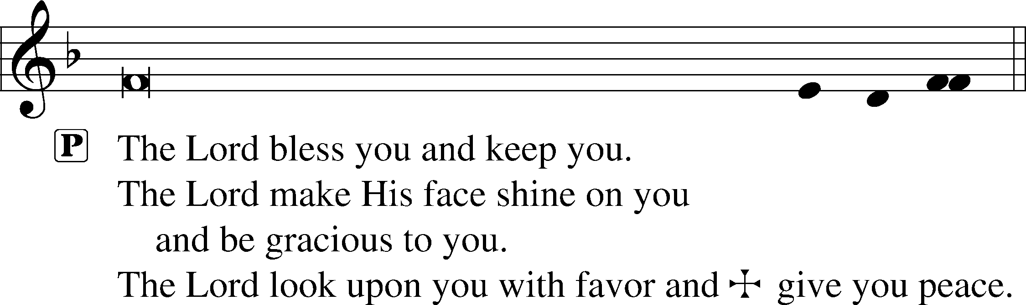


Hymn Man of Sorrows
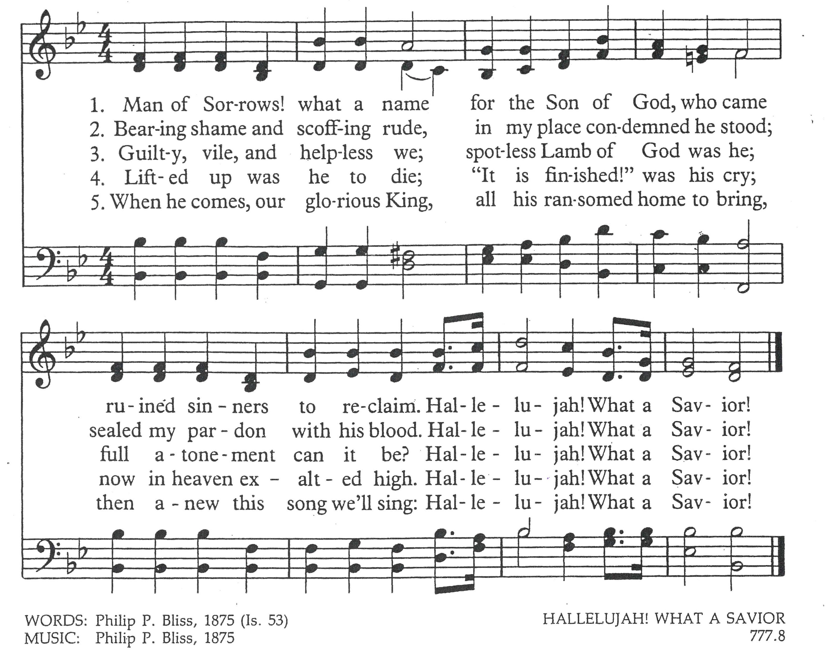

Acknowledgmnts
Divine Ser ce, Setting One from Lutheran Service Book
Unless otherwise indicated, Scripture quotations are from the ESV® Bible (The Holy Bible, English Standard Version®), copyright © 2001 by Crossway, a publishing ministry of Good News Publishers. Used by permission. All rights reserved.
Created by Lutheran Service Builder © 2026 Concordia Publishing House.

Prayers and Announcements
In Our Prayers: Dixie Davidson (had cataract surgery last Wednesday), Hudson Blackburn ( Evelyn’s great-grandson, receiving 3rd cast on Tuesday), Velvet Fackeldey (recovering), De Stirling (recovering from knee replacement surgery), Michelle Newell (recovering from procedure on Wednesday), Cori Grunwaldt, Cathy Davis, Bill McGuire (Velvet’s son-in-law)
Shut-In: Jen Perry, Peggy Avers, Gaylene Peters, Kathryn Haller, Brian Pendergrass, Jeanette Seeman, Bill & Helen Donald; In the Military: Joshua Carlson, Alex Douglas, Roberto Baquerizo & Kaiden Stirling (Navy –DeArta’s grandsons), Patrick Gardner (Jacobsen’s grandson), Clay Marlin, James Beall, Zach Sparks, and those we think of privately.

Fall has arrived in the Country Store! Check out our new items!

Issues, Etc.: Book of Proverbs Bible Study…The Word of the Lord Endures Forever is a daily 15-minute verse-by-verse Bible study produced by Lutheran Public Radio in Collinsville, IL and hosted by LCMS Pastor Will Weedon. You can listen at your convenience at thewordendures.org, Amazon Alexa, Google Home, Apple HomePod, Tune In, the LPR mobile app and a podcast provider.

Birthdays & Anniversaries for this week: Today – Jeff & Dorothy Loges, Ann.; Tuesday – Ryan Harris; Wednesday – Gabe Marlin, Jeff & Sandy Dautenhahn, Ann.; Thursday – Katie Marlin; Friday – John & Lou Gadd, Ann.

Daily Bible Readings: Monday –1 Thess. 5:12-28, 2 Kings 10:1-36; Tuesday – 1 Tim. 1:1-20, 2 Chron. 22:1-12; Wednesday – 1 Tim. 2:1-15, 2 Chron.23:1-21; Thursday –1 Tim. 3:1-16, 2 Chron. 24:1-27; Friday –1 Tim. 4:1-16, 2 Kings 14:1-29; Saturday – 1 Tim. 5:1-25, 2 Kings 15:1-38.

Stewardship of Souls & Finances
Worship Attendance General Offering Last Week
9:00AM - 81 $3,046.00
Bible Class - 20 Needed for Budget: $4,458.67

Upcoming Events
14 Sept Church Council Meeting, 6:00PM
15 Sept LWML Bible Study, 5:30PM
17 Sept Open Hands Mission to the Blind, Noon
27 Sept Voters’ Meeting, 10:30AM
04 Oct LWML Sunday & Business Meeting,
11 Oct Oktoberfest, Noon – 3:00PM
31 Oct Trunk or Treat, 5:30PM

Serving Today Serving Next Week

Organist Joy Gaines Joy Gaines

Lector Jeff Carlson Jeff Loges

Elders Jeff Carlson Jeff Loges
Nick Grunwaldt Nick Grunwaldt

Usher Todd Kelm Jansen Cheek
Bill Heller Matt Sosnowski

Altar Gld Sheila Carothers Linda Werner

Coffee Bar Jeanette Ferkey De Stirling
Allison Meyer Cheryl Oberdieck

Weekly Calendar
Today 9:00AM Worship/Communion
10:30AM Sunday School & Bible Class

Tues. 5:00PM Board of Trustees’ Meeting

Thurs. 9:30AM Thursday Girls
10:00AM Men’s Bible Class

Sun., 9:00AM Worship/Communion
9-06 10:30AM Sunday School & Bible Class

